Vanessa and Adam’s games and activities: Overview, instructions and templates (version 9) April 2016
Adam Edwards and Vanessa Hill: The Sheppard Library, Middlesex University
Contents
Introduction 3
Workshops for Computing Students 4
Foundation 5
Words are powerful things: ‘Cup of tea’ exercise 5
Hands on exploration of resources including ‘More to life than Google’ 6
Evaluating information 7
Dewey game 8
1st year UG workshop 9
Thinking about resources: card game 9
Constructing keywords: Fruit market exercise 10
Self-exploration of resources 11
Evaluating resources 11
2nd year UG workshop 13
Keyword images activity 13
Envelope activity: self-exploration of resources 13
Evaluation game 14
3rd year UG workshop 16
http://www.slideshare.net/EISLibrarian/bis3400-feb-2016 16
Reference list game: using the right information for your project 16
Constructing keywords: Common project 17
Constructing keywords: Individual projects 17
Self-exploration of resources 18
Ranking evaluation criteria 18
Post graduate workshops 20
http://www.slideshare.net/EISLibrarian/cce4900-dec-2015 20
Sources game 20
Constructing keywords: Common project 20
Constructing keywords: Individual projects 21
Self-exploration of resources 21
Evaluating resources 21
Workshops for Product Design students 23
1st year workshops for UG Product Design students 24
Session 1 (1 hour) Getting Started: Resources 24
Session 2 (1 hour) Getting curious: information to feed your creativity 24
Session 3 (1 hour) Finding information: different resources 25
2nd year workshop for UG Product Design students: Finding what you need 27
3rd year workshop for UG Product Design students: Information skills for research 29
Games we no longer use 30
Scenario game (3rd year students) 30

Introduction

Our aim in developing these activities and games is to encourage deeper learning of information literacy skills through:
- engagement with the learning process
- interaction with peers and librarian
- reflection on what is already known and what has been learnt in class
- discussion around topics
- peer learning amongst the class
We believe it is better to cover a small number of topics in detail than to try and cram too much in to a workshop. We do not use on screen demonstrations, as this does not encourage users to experiment or think about what they are doing.
All our sessions include a range of varied activities and games to cover the core components of:
- Thinking about resources
- Constructing keywords (Search terms)
- Exploring resources
- Evaluation of information
Our use of games was inspired by Susan Boyle’s (Librarian: UCD) presentation at LILAC 2011.
Our teaching and learning principles were inspired by Sharon Markless (Senior Lecturer Higher Education, Kings College London), in particular ‘Teaching information literacy in HE: What? Where? How’ which she presented at CILIP Dec 2010.
Other people have also inspired and influenced us including library colleagues from Middlesex University, Phil Bradley (Information Specialist and Internet Consultant), Amanda Clossen (Librarian: Penn State University) and Alan Turner (Librarian: Art University Bournemouth).
This document describes how we provide information skills training for two of our subject areas: Computing and Product Design.
Templates for all our games and activities plus worksheets are available alongside this document in JORUM and the relevant game, activity or worksheet is noted at the end of each section below.
If you would like more information, please email: Dr Adam Edwards (School Liaison Manager) a.edwards@mdx.ac.uk or Dr Vanessa Hill (Service Development Liaison Librarian) v.hill@mdx.ac.uk

Workshops for Computing Students

A typical workshop for computing students comprises of:
- Thinking about resources
- Constructing keywords (Search terms)
- Self-exploration of resources
- Evaluation of resources
These four elements form the basis of all workshops from Foundation through to PG. We use different games and activities ateach level.
Workshops for 1st and 2nd years will take around 90 minutes which avoids information overload. 3rd year and post graduate workshops take longer (120 mins) as we cover more resources such as citation indexes and bibliographic management software.
Workshops are always linked to a current student project (with the exception of 2nd year computing students) and where possible we will include the coursework marking criteria. This criteria is a good way of showing the link between use of library support and resources and achieving better grades.
Slides for use with all our activities can be found in the Library Subject Guide for Computing in the Information Skills section here: http://libguides.mdx.ac.uk/computing/ComputingWorkshops. These change and get updated, so if you cannot find what you are looking for, please email us.
Workshops and activities for computing students are described below:

Foundation

Our workshop for Foundation students is shown in the following link:
http://www.slideshare.net/EISLibrarian/foundation-feb-2016
The workshop follows the basic layout (4 components) as described above and is intended to introduce students to a selection of library resources and their value in student academic work. The workshop also encourages students to think about using a range of words to describe a topic and evaluation of information found.
Students on our Foundation course follow a number of subject strands including psychology, media, business and computing. However our workshop is part of their skills module which is generic to the whole programme.
A typical Foundation workshop is described below:

Words are powerful things: ‘Cup of tea’ exercise
The idea of this game is to get students thinking about all the different words that they can use to describe a topic.
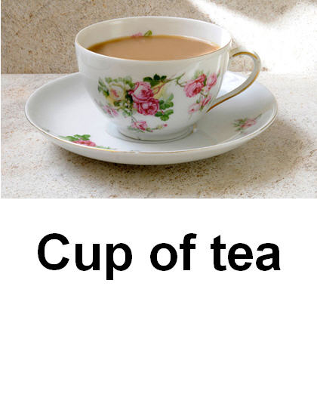
Students are divided into small groups. Each group is given a card which includes an image and a description of what the image is e.g. ‘Cup of tea’. Each group has a different image and must be careful to ensure that the other groups do not see their image. The groups are then asked to note down on flip chart paper as many words to describe the image without using the words they have been given i.e. if a group has the ‘Cup of tea’ card (right) they might note down the following words, but cannot use ‘cup’ or ‘tea’:
- Container
- Liquid
- Hot
- British
- China
- Saucer
- Refreshing
- Mug
- Infusion
- Milk
- Assam
- PG Tips etc
After about 10 minutes, each group in turn shows their list of words to the rest of the class who must try and guess what the image is.
The groups are then asked to note down as many words to describe their current project (‘Digital Natives and Learning’ in our example) and these will be used in the next part of the workshop when they have a go at using our resource discovery tool ‘Summon’.
See: Foundation Cup of tea game.docx

Hands on exploration of resources including ‘More to life than Google’
Students are given the opportunity to explore a number of library resources. This part of the workshop also provides the opportunity to consider the range of resources available to students and how they can enhance their academic work.
Firstly students are asked to search for information for their current project using our resource discovery tool ’Summon’. We do not demonstrate use of Summon, although we do explain how they can access it and what it covers. We are on hand to answer questions and offer advice, as well as pointing out the reference creation tool on Summon and other useful features such as how to refine a search.
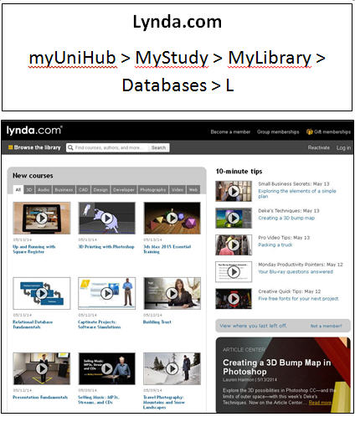
Secondly the students explore other library resources in groups. This activity is referred to as ‘More to life than Google’ to encourage understanding that there are other to find information for their academic work. It is a simpler version of the ‘Envelope’ activity used in our 2nd year computing workshops.
Students are divided into groups. Each group is given a card which describes details of one library resource. The resources we include are:
- Library catalogue
- Lynda.com
- Cite Them Right Online
- Library Subject Guides
- Britannica Online
- Box of Broadcasts
Each group must spend approximately 20 minutes exploring the resource they have been given and be prepared to demonstrate it to the rest of the class using the Librarian’s computer/projector/screen.
They need to consider the following points:
- What is it?
- Useful/interesting features.
- Limitations.
- How they could use this resource in their studies.
As the students explore their resource, the librarian can circulate round the groups and prompt them to look at specific things e.g. ask students who are exploring the library catalogue to find out how to see where a book is shelved, how to request a book and log in to their accounts. When each group demonstrates their resource, librarians should prompt as necessary, but not take over. Leave the students to describe the resource in their own language and point out the features that THEY think are useful.
See: Foundation resources cards.docx

Evaluating information
This activity is intended to get students thinking about the quality of the information they find. The activity should take about 30 mins.
Students are divided into groups and given a worksheet which asks them to evaluate 4 information sources on the topic of Digital Natives. These 4 items are located on one of our Library Subject Guides (http://libguides.mdx.ac.uk/Foundation) and include:
- CNN Blog post
- Academic Journal Article from British journal of Educational technology
- Wikipedia article
- Urban Dictionary (website) definition
(Please note that one of the links on the website is to a journal subscribed to by Middlesex University, so people outside of the University will not be able to access this item).
Using the worksheet, each group should consider how they know if the information is reliable.
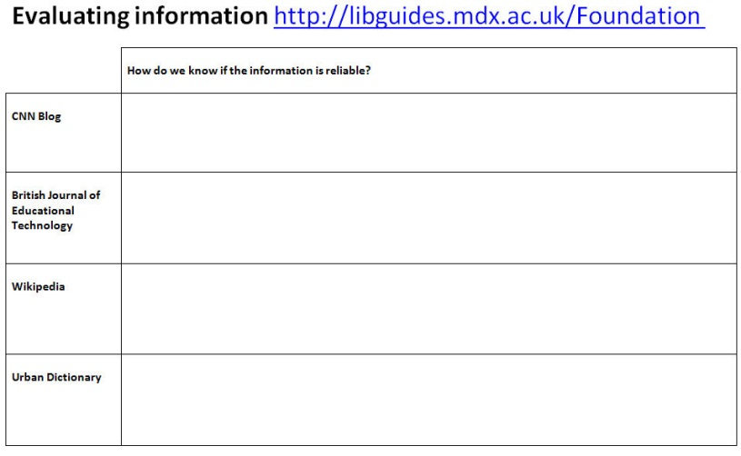

When all groups have finished, take feedback and discuss issues around academic authority, peer-review, reliability etc.
Sum up with a slide showing authority, relevance, intent, objectivity and currency to consolidate the issues raised and discussed.
See: Evaluating search results Foundation.docx

Dewey game
The Dewey Game is occasionally used in workshops for Foundation students when time permits. This game was initially created by our library colleague Vivienne Eades, but adapted by us to resemble book covers and incorporate issues such as different loan statuses, editions etc. This is designed for Foundation students and is done as a whole class activity usually at the end of the session. If the class is small then make use of any staff present to pretend to be human books.
Make the cards: You will need to create 12 A4 laminated cards for books for their subject. Make sure you include:
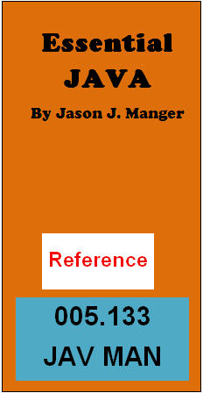
- Simple and long numbers
- Alternative editions
- Different loan periods
- Similar numbers with different suffixes
- Any peculiarities e.g. we use a double suffix for software books e.g. 005.133 JAV SMI for books on Java programming.
- Each card has Not on shelf on the back.
In class, volunteer 12 students to be the books. Give each student volunteer a card. They stand in a row and hold the cards up. Then get the rest of the class or a couple of students to be the librarians and put the books in order. This means moving the people with their cards. The books are not allowed to help! The rest of the class can join in with suggestions or heckling!
Once they think the books are in order, check and then raise issues such as different loan periods, what ‘reference’ means, different editions, Dewey numbers mean subjects etc.
Then get two students to turn their cards round to say ‘Not on shelf’ and ask what we should do? This provides the opportunity to mention reservations, inter library loans or book purchase suggestions etc.
See: Dewey Game CS.docx

1st year UG workshop

See the link below for a typical 1st year workshop (BIS1100). This workshop is called ‘Better than Google’ to directly challenge student overuse of Google and demonstrate the value of using academic resources provided by the library and the ease of access. The presentation shows how we use each game in a context of feedback and discussion:
http://www.slideshare.net/EISLibrarian/bis1100-nov-2015
A typical 1st year workshop for computing students is described below:

Thinking about resources: card game
This is designed for 1st year UG students, but has been used successfully with direct entry third years and post graduate students unfamiliar with western higher education and information searching.
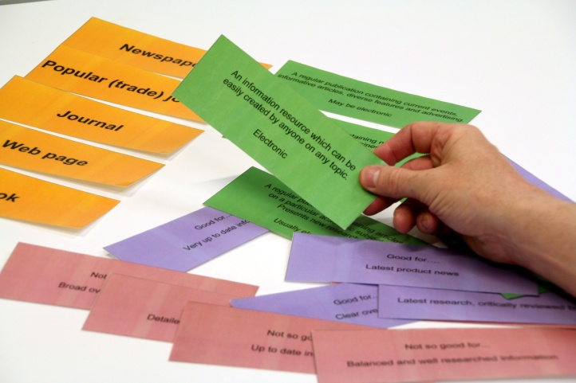
First make your cards. Aim to have a set of cards for every 3 students i.e. you will need 10 sets for a class of 30. Each set consists of 20 cards (i.e. 5 yellow resources cards, 5 green definition cards, 5 pink ‘Not so good for’ cards and 5 purple ‘Good for’ cards). Laminate the sheets and cut them up into individual cards. Secure each set of 20 cards with elastic bands.
The game aims to get the students thinking about the value of good quality information sources in their academic work. When asked, they will usually admit that ‘Google’ is their preferred information source.
Working in groups of 3 they have 10 minutes to match a definition, a ‘good for’ and ‘not so good’ card against each resource type e.g. Website or Book.
When the game is completed take feedback. Ask a group to give you the definition of one of the resources e.g. Book, then the ‘good for’ and finally the ‘not so good for’. Follow up with discussion regarding the resource e.g. with books we would discuss why they are good for a broad overview of the subject, but also why they can be out-of-date etc.
Do the same with each other resource. Things we raise during feedback are:
- Webpage: Anyone can create them, not necessarily checked for accuracy, do not know who the authors are on pages like Wikipedia etc. There is usually quite a lot of discussion around use of Wikipedia, so we try to stress that while it is a good starting place to get keywords, it should not be used and referenced in academic work.
- Newspaper: Issues of bias and especially sensationalist style of the British tabloids.
- Academic Journal: Ask what’ peer review’ means and explain how the process works. Discuss the value of using this sort of resource in academic work and why lecturers will prefer them.
- Popular trade journal (magazine): ie what you might buy at a newsagents. Point out similar risks to newspapers such as bias or promotion of products e.g. Mac User will never say PCs are better than MACs. Also discuss positives i.e. up-to-date, latest news etc
- Books: Good overview of a subject, but can be out-of-date, many books now available electronically, editorial control, different editions etc.
Sum up that the library enables access to quality resources for their studies. They will need to use websites, newspapers and popular journals with care, but should ensure that most of their references are from books and academic journals.
See: Types of resources All years.docx

Constructing keywords: Fruit market exercise
This is best done as a whole class activity or you can give out the worksheets and ask students to think about keywords in groups.
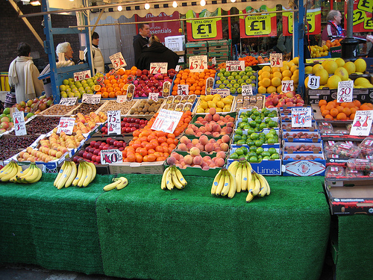

http://www.flickr.com/photos/rossjamesparker/89414788
- Start off with the fruit market image. We include it in our presentation, so everyone can easily see it.

- Opening question: What do you see in the picture? Answer will usually be fruit.

- Ask them to be more specific and they will probably say Bananas. Get them to say a few more ie. apples, strawberries etc. Explain that searching for fruit is like searching the library for a book on computers or management. You will get far too many vague results. Searching for bananas is like searching for computer networks or financial management tools. Be as specific as you can.

- Then ask about the people in the image i.e. who are they? You will probably get customer so ask for synonyms e.g. client, shopper, buyer, consumer etc. The old lady/OAP/pensioner/senior citizen/elderly lady is another example. Point out the need to use a variety of words as different databases use different terminology or use USA English. Give examples from your subject.

- Ask about the bigger picture i.e. things related to the picture which are not in it e.g. nutrition, economy etc. Again get them to think of other terminology e.g. vitamins and minerals, 5-a-day, health, or competition, high street economy, credit crunch and so on.

- Finally ask which fruit names have a double meaning in a technical sense i.e. Apple, orange, blackberry and raspberry (pi) should be mentioned. Point out the problems of false positives and double meanings and therefore the need to use several keywords in combination or refining tools (the Library Subject Guides for our subjects have a section covering search tips such as the use of quotation marks to search for a phrase e.g. “project management”).
Then repeat the exercise using a real current project, either as a whole class or as small groups. A worksheet can be used if running as a group exercise. The keywords they come up with are then used to search for information using our resource discovery system (Summon).
See: Thinking about Keywords Fruit market 1st year.docx
See: Thinking about keywords general worksheet.docx

Self-exploration of resources
We do not use a game for this part of the workshop, but ask students to search Summon, our resources discovery tool, for information relevant to the project they are currently working on. We do not demonstrate use of Summon, although we do explain where they can access it and what it covers. We are on hand to answer questions and offer advice, as well as pointing out the reference creation tool on Summon and other useful features such as refining tools.

Evaluating resources
This is designed for first year UG students, but has been used with direct entry third years and post graduate students unfamiliar with western higher education and information searching.
Each group (ideally 3 people) is given a pack of 4 photocopied items (academic journal article, newspaper article, trade journal article and Wikipedia article) on a subject related to their studies. We use ‘Network security’ for all computing students, and the 4 items are genuine search results.
Our 4 items include:
- A peer reviewed journal article, which has citations, references, biographies of authors, but is over 10 years old.
- A trade journal article from a title linked to a retailer, which ranks the product they sell as being superior. It’s up-to-date, but bias.
- Wikipedia article, which is very up-to-date, but has no authority.
- Newspaper article from The Sun, which is sensationalist and uses non-academic language.
The students are asked to pretend that they are researching an essay on ‘Network Security’ and these are some of the items that they have found. We ask them in groups to consider a range of questions using the worksheet (see below) e.g. which items are relevant, contain bias, could not be used, have the most academic authority and which is the most up-to-date.
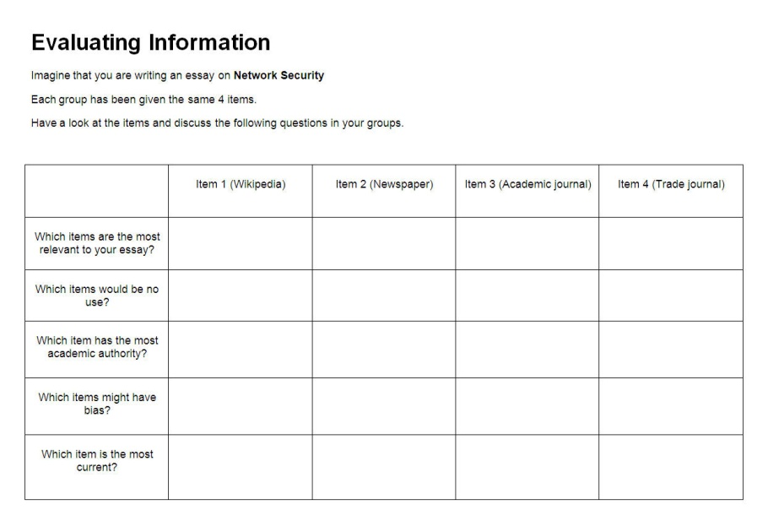

Once activity is completed, follow with feedback and discussion. We then conclude by saying that none of these is good enough to use as all are flawed in some way. Therefore more searching required in order to fins quality and relevant resources.
See: Evaluating Resources Network security.docx

2nd year UG workshop

Workshops for 2nd year students follow the same basic layout as those for 1st year workshops i.e. Thinking about resources, constructing keywords, self-exploration of resources and evaluation. However we have developed different games and activities intended to get students curious about their academic work and projects. See the following link for a typical 2nd year computing workshop (CCE2060):
http://www.slideshare.net/EISLibrarian/cce2060-oct-2015

Keyword images activity

This activity was initially created for 1st year Product Design students (see section on ‘Workshops for Product Design students’), but has been successfully used with computing students.
A random image is used as a metaphor for a student project. Students are expected to use lateral and creative thinking to research a random image, in the same way that they need to approach a new unknown subject when a project is set by their tutor.
Students are divided into groups (ideally 3 students) and given a worksheet which includes an image (see example right). Students are asked to note on the worksheet ‘What it is?’ i.e. what do they see in the image. They then need to list as many words as they can think of to describe the image. Students may need prompting, as often they do not know what the image is of. Encourage them to write down what they see, even if they don’t know what it is.
Using Google (or their preferred search engine), students then need to search for 3 interesting or surprising facts connected with the image and also note down how they found these facts.
Each group then presents their findings to the rest of the class, describing the keywords/search terms that they used.
This exercise takes about half an hour.
See: 2nd year Computing keywords.docx

Envelope activity: self-exploration of resources
This activity was inspired by a teaching technique used by Phil Bradley in a workshop presented at Euston House, London on 11th March 2014 on behalf of UKeiG ‘Using multimedia tools to present information’. In this workshop Phil handed an envelope of resources to each delegate (hence the name), who then could select those resources of interest to them and investigate. This activity gets students both thinking about what different resources available to them, as well as exploring a range of diverse resources in their own way.
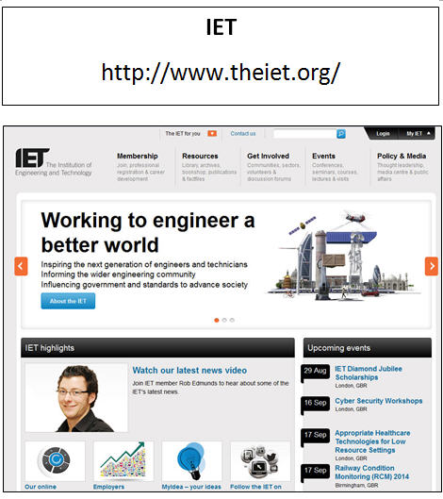
To make this activity, you need to create a number of cards, each one depicting a resource relevant to the subject area. In our case we have 24 x laminated A4 cards which depict a range of Middlesex University subscribed or open access resources relevant to computing. Resources include:
- IET website
- Ted talks
- IEEE.TV
- Cite Them Right Online
- Easelly
- Project Smart
- BCS website
- Britannica Online
- Computing Library Subject Guide
- Box of Broadcasts
- British Standards online
- BBC News Technology
- Computing Research Repository etc.
Students are divided into groups (ideally 3 students) and each group is given 4-5 of the cards. Each group then has approx. 20mins to look at all the resources and choose the one that they think would be most useful to their studies.
Each group then presents the resource to the class using the demonstration computer, and should note in particular:
- What it is?
- Useful or interesting features
- Limitations
- How it could be used in their studies.
See: 2nd year resources cards.docx

Evaluation game
This game was inspired by Amanda Clossen, Learning Design Librarian, from Penn State University, USA in her presentation at the Information Literacy Satellite Meeting (IFLA World Library and Information Congress 2014) at Limerick, Republic of Ireland, Aug 2014. It is intended to get students thinking about the provenance of information, how it is created, why it is created etc.
This game is made in the same way as the 1st year ‘Thinking about resources’ game and comprises 22 laminated cards. The game is ideally played in groups of three, so for example 10 sets will be required for a class of 30.
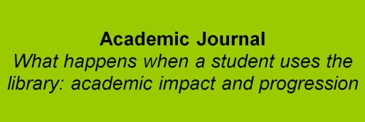

Each pack contains 2 black cards labelled Authority and Currency, plus a duplicate set of 10 cards depicting a range of information sources from a Tweet and Blog Post through to a Conference proceeding and a Movie.

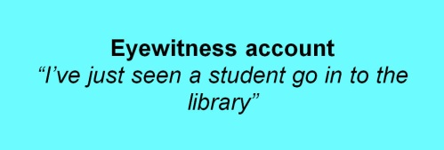
The activity starts with a discussion around the meanings of the words currency and authority in the context of information i.e. Currency: how old, last updated, what has been updated; Authority: who is the author, what are their qualifications and how has the information been verified?
Each group is then given a pack of cards. Students must rank each set of information sources against the two black cards Authority and Currency. The way the students rank the resources will vary (this is fine), but will look something like this:
Authority | Currency
Academic journal | Eyewitness account
Conference paper | Tweet
Book | Blog post
TV documentary | TV news report
Newspaper article | Newspaper article
TV news report | TV documentary
Blog post | Conference paper
Tweet | Academic journal
Eyewitness account | Book
Movie | Movie

End the activity by taking feedback from the class and leading discussion e.g. which source offers the most authority, which source has the least currency, when do blogs and Tweets have more authority, when are eyewitness accounts useful? Etc.
See: 2nd year evaluation game.docx

3rd year UG workshop

Workshops for 3rd year students follow the same basic layout as for other years i.e. Thinking about resources, constructing keywords, self-exploration of resources and evaluation. Different games and activities are used for 3rd year workshops which generally last 120 minutes and students are introduced to a wider range of library resources. See the following link for a typical 3rd year workshop:

http://www.slideshare.net/EISLibrarian/bis3400-feb-2016

Reference list game: using the right information for your project
This game has been designed for 3rd year students and is a variation of the 1st year ‘Thinking about resources’ game.
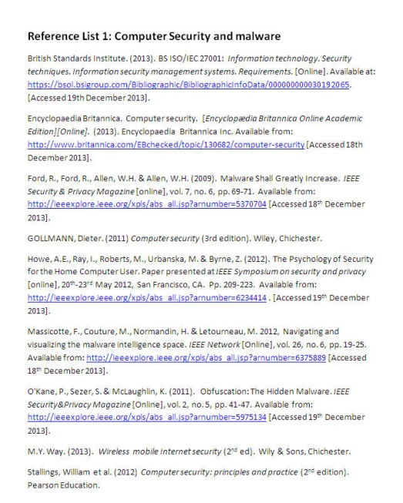
The game is played in groups of 3 and is intended to make students think about the information sources they should use to support their written work. We usually show an example of marking criteria used for student work before we play this game, which demonstrates how using the library can improve their grade e.g. 10% of total marks given for use of good quality and relevant information sources.
Students are asked to look at 3 reference lists about computer security and malware, which they need to mark against various criteria such as relevance to the project and quality of the resources used.
Each list varies in its quality e.g. List 1 uses a range of good quality, up-to-date resources, but there are a couple of errors with the Harvard referencing. List 2 includes lots of websites including Wikipedia, an out-of-date book and an irrelevant newspaper article. The Harvard referencing is poor. List 3 is the mid-range list including a variety of sources of varying currency.
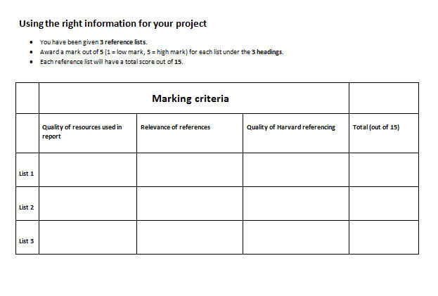
Once all groups have completed, take feedback. Students are asked what marks they gave each list and why. Discussion should raise issues of use of appropriate resources for academic work, and the value of using academic journals and conference proceedings etc.
NB: The attached file includes the student worksheet, 3 x reference lists for student activity and 3 x reference lists (named ‘correct’) for the librarian. In the latter, missing parts of the Harvard references are included and highlighted in yellow.
See: Reference List game consolidated V2.docx
See: Right information.docx

Constructing keywords: Common project
When the students have a common project, we run the keyword exercise as for 1st year students using the fruit market stall image.
Then repeat the exercise using a real current project, either as a whole class or as small groups. A worksheet can be used if running as a group exercise.
If students have individual projects, see below (Constructing keywords: individual projects).
See: Thinking about keywords general worsheet.docx

Constructing keywords: Individual projects
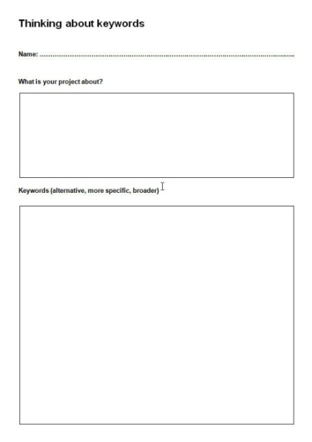
When students are working on individual projects, we use the following exercise.
Run the ‘Constructing keywords’ activity (Fruit market stall picture) as described above for 1st year workshops. Then give each student a ‘Thinking about keywords’ worksheet. Ask them to note down their name and project details on the worksheet. The worksheet should then be passed to the person on their right.
The next person should note down any keywords associated with the project that they can think of. The worksheet should then be passed to the next person to add further keywords and so on.
After 10-15 mins, the worksheet should be returned to the owner, who hopefully will get some keywords and ideas that they had not thought of. These keywords can be used when searching our resources.
See: Thinking about keywords worksheet 3rd years.docx

Self-exploration of resources
We do not use a game for this part of the workshop, but ask students to search our resources for information relevant to the project they are currently working on. We will initially ask students to use Summon our research discovery tool, but will also introduce them to specialist journal databases such as ACM Portal, IEEE Xplore and British Standards Online.
We do not demonstrate use of these resources, although we do explain where they can access them and what they cover.

Ranking evaluation criteria
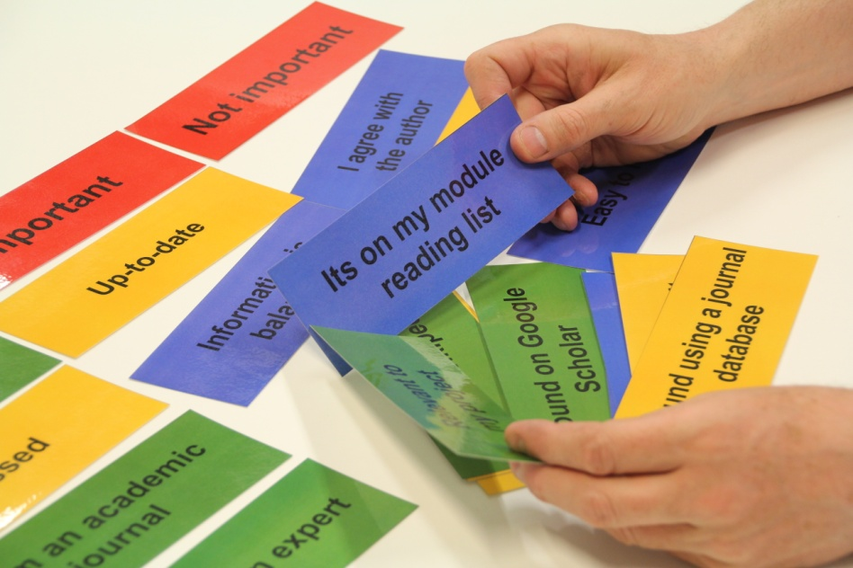
This is designed for third year UG students, but has also been used successfully with PhD students. The game is played in groups of 3 and is a variation of the 1st year ‘Evaluating resources’ game. It is intended to get students thinking about the criteria they might use when evaluating information for quality.
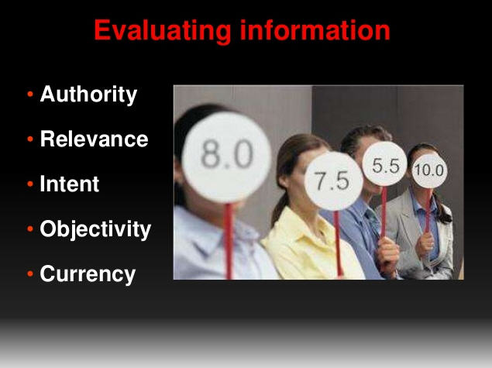
Hand out a pack of cards to each group (ideally 3 students). Each pack contains 3 red cards ‘Very important’, ‘Important’ and ‘Not important’ plus 20 ‘criteria’ cards e.g. ‘Up-to-date’, ‘Written by an expert’, ‘Found using a journal database’ etc. Each group needs to consider the different criteria and decide how important that criteria is when selecting information for use in their academic work. For example if they consider ‘Up-to-date’ to be ‘Very important’, they should place this criteria card by the ‘Very important’ card.
The game should take 5-10 mins. If a group completes the task quickly, then ask them to rank the ‘Very important’ criteria.
When all groups have completed the task, take feedback e.g. ask a group what criteria they consider as ‘Not important’ and why? Then ask another group what they consider as ‘Very important’ and so on. This should bring out issues like peer review, citation count, or related to use of Google Scholar or Wikipedia etc. Be prepared for differing opinions, as some of the criteria ranking can vary depending on the students. For example, it might not always be important that information has lots of references, is written by an expert or is balanced.
You don’t need to cover every card as they will have discussed them all in their groups, but make sure that the most significant issues are covered.
Sum up with a slide showing authority, relevance, intent, objectivity and currency to consolidate the issues raised and discussed.
See: ranking eval criteria game 3rd years.docx

Post graduate workshops

Workshops for PG students follow the same basic layout as for other years i.e. Thinking about resources, constructing keywords, self-exploration of resources and evaluation. Different games and activities are used and workshops generally last 120 minutes. Students are introduced to a wider range of library resources. See the following link for a typical M-level workshop (BIS4430):

http://www.slideshare.net/EISLibrarian/cce4900-dec-2015

Sources game


This is a variation of the 1st year 'Thinking about resources' game and is intended to get students thinking about the value of a wider range of resources.
Each pack consists of 25 cards. Create cards in same way as described for the 1st years Computing ‘Thinking about resources’ card game.
Students work in groups of 3 to match different resource against three criteria: ‘Trustworthy’, ‘Be suspicious’ or ‘Risky’. This activity should take about 10 mins. Cards cover conventional sources such as academic journals, textbooks and British Standard, but also things like Wikianswers, Blogs and Friends.

Once all groups have completed the activity, take feedback. As with many of our games, there are no right or wrong answers, and the objective is to provoke discussion and understanding of the different types of resources available to students, which ones can be relied on for quality and which ones need to be used with caution. The usual issues will be raised during discussion, such as the value of peer reviewed journals, bias in newspapers, trade journals, company websites; and the way that information can be misused for example statistics.
See: Sources game.docx

Constructing keywords: Common project
When the students have a common project, we run the keyword exercise as for 1st year students using the fruit market stall image. Then repeat the exercise using a real current project, either as a whole class or as small groups. A worksheet can be used if running as a group exercise.
If students have individual projects see below (Constructing keywords: individual projects).
See: Thinking about keywords general worsheet.docx

Constructing keywords: Individual projects
When students are working on individual projects, we run the ‘Constructing keywords’ activity (Fruit market stall picture) as described above. Then give each student a ‘Thinking about keywords’ worksheet and run activity as described for 3rd year workshops.
See: Thinking about keywords worksheet PGs V2.docx

Self-exploration of resources
We do not use a game for this part of the workshop, but ask students to search our resources for information relevant to the project they are currently working on. We will initially ask students to use Summon our research discovery tool, but will also introduce them to specialist journal databases such as ACM Portal, IEEE Xplore, and British Standards Online, as well as Citation Indexes.
We do not demonstrate use of these resources, although we do explain where they can access them and what they cover.

Evaluating resources
This activity is designed post graduate students and is played in groups of 3. It is intended to get students thinking about the reliability and quality of the information they find. The activity should take about 30 mins.
Each group is given a worksheet which asks them to imagine that they are researching ‘The right to be forgotten’. We chose this subject because it is topical and is generic enough to be used across all the subject areas that we support.
Students are then asked go to a website and look at a number of items which address this subject. The items we have chosen include:
- An article on a personal blog about privacy, human rights, law and the Internet which is authored by an academic who is an expert in the field (no references)
- Wikipedia (random selection of references)
- Article from the Guardian newspaper (no references)
- Peer-reviewed academic journal article (lots of references)
- Article from BBC News Technology page (no references)
The website can be viewed here: http://libguides.mdx.ac.uk/EvaluatingInformationPG (Please note one of the links on the website is to a journal subscribed to by Middlesex University, so people outside of the University will not be able to access it).
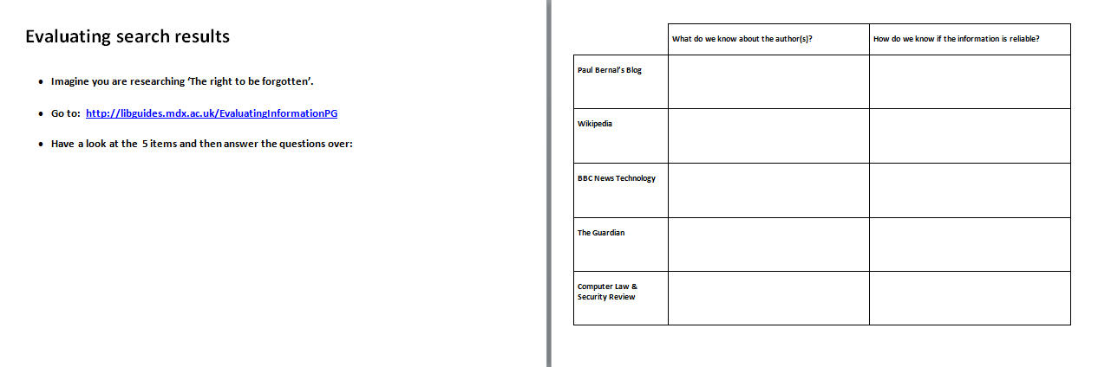
Having looked at the items, the groups are asked to answer the following questions and write their answers on the worksheet:
- What do we know about the authors?
- How do we know if the information is reliable?
When all groups have finished, take feedback and discuss issues around academic authority, peer-review, reliability etc.
Sum up with a slide showing authority, relevance, intent, objectivity and currency to consolidate the issues raised and discussed.
See: Evaluating search results PG.docx

Workshops for Product Design students

The main issues with these students, particularly 1st year Product Design students are:
- Getting them into the Library
- Making the library seem relevant to their work
- Getting them to search the Internet more effectively (it is a valid source for them), but not to rely on it completely
- Making them understand the value of academic resources in their work ie. there is more to life than Google

Since 2011 we have worked closely with the 1st year Product Design tutors to rework the information skills workshops offered to their students. It was obvious from previous years that these students did not respond to lengthy, traditional, didactic workshops, and that shorter regular workshops might be more palatable.
Inspired by a Sharon Markless workshop we decided to let the students discover the library and its resources for themselves and tell us why something is useful, rather than the other way round. Over the next couple of years we experimented with various lesson plans and activities, which did appear to engage the students, whilst introducing them to the library and the information searching process.
Summer 2013 we attended an ARLIS workshop as presenters, and were inspired by a presentation by Alan Turner and his ‘Ideas factory’ at Arts University Bournemouth, where he encouraged the students to get curious and enhance their work through research and discovery. This got us thinking about how we could refine our workshops further. Following discussion with the 1st year tutors, we made a number of changes introduced in 2014/15 and we continue to develop and enhance these sessions. We have since rolled out information literacy workshops to 2nd and 3rd years which build on the 1st years workshops. These are described below:
A selection of our presentations can be seen here:
http://libguides.mdx.ac.uk/pdde/PDworkshops
These presentations change and get updated, so if you cannot find what you are looking for, please email us.

1st year workshops for UG Product Design students

Session 1 (1 hour) Getting Started: Resources
Our presentation can be seen here:
http://www.slideshare.net/EISLibrarian/babsc-product-design-1st-year-session-1-oct-15
- This session is held in our Materials Room (home of our Special Collections).

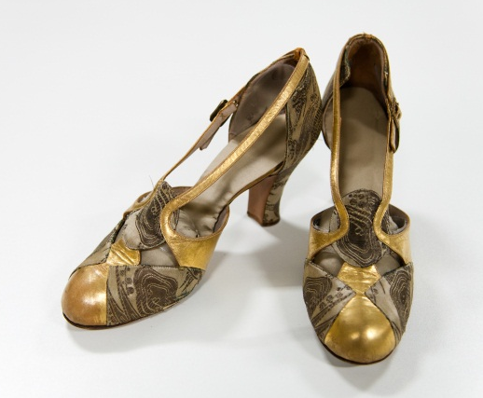
- We start off by running the ‘Thinking about resources’ game to get students thinking about the range of resources available and their value in an academic context. We use a slightly different version to the one used with computing students, which includes ‘Objects’ as a resource. Feedback and discussion follow in the usual way. See: Types of resources All years PDE.docx

- Then in groups (ideally 3 people), the students are given a box of 5 items/objects from our special collections. Each box is different. As an example one box includes a hat from the fashion collection, item of building material from the Samples Library, some library date stamps from our Hornsey College of Art Archive, Great Exhibition Catalogue 1851 and a 1930s A-Z of London.

- Students have 15 mins to examine their items and complete a worksheet, which requires them identifying certain aspects of the items such as date of manufacture, what it is made of, what it could be used for etc. See: 1st yr PD session 1 worksheet.docx

- Each group are asked to choose their favourite item, talk about it and discuss how they can find out more ie. what keywords they can use, paths they can follow etc.

- Students report back to the whole class.

- The session is lively and fun and portrays the library as interesting and exciting. Although we do not go into detail about the Special Collections, students now know enough, and quite a few have come back to further explore.

Session 2 (1 hour) Getting curious: information to feed your creativity
Our presentation can be seen here:
http://www.slideshare.net/EISLibrarian/babsc-product-design-1st-year-session-2-nov-15


- Session is held in a teaching room (with computers) in the library.

- The session is aimed at developing student curiosity and demonstrating how research can feed their creativity and make their finished products/designs better.

- The tutors have requested that we focus at this stage on searching the Internet, and making the students better searchers through use of keywords and search tips.

- We start off by running the keyword activity using the fruit market stall image as described for 1st year Computing workshops.

- Then in groups (ideally 3 people), students are given an image (and worksheet) to investigate on Google, noting 3 interesting/fun facts connected with the image, plus how they found this information. They can search for any aspect of the image that interests them. Each group is given a different image. See: 1st year product design session 2 worksheets V2.docx

- Groups give feedback to the rest of the class including their 3 interesting/fun facts, and how they carried out their search, what keywords used, what worked, what didn’t work etc. This use of images has subsequently been introduced into 2nd year computing workshops with much success.

- The session ends with a couple of extra slides on image searching and other library resources at the request of the tutor.

Session 3 (1 hour) Finding information: different resources
Our presentation can be seen here:
http://www.slideshare.net/EISLibrarian/pde-session-3-feb-16
- Session is held in a teaching room (with computers) in the library.

- This workshop aims to enable students to discover a wider range of information sources both open access on the Internet and those provided by the library.

- The first activity is similar to the ‘Envelope activity’ used in 2nd year computing workshops (see above), but includes resources relevant to product design. Students are divided into groups (ideally 3 students) and each group is given 4-5 of the cards. Each group then has approx. 20mins to look at all the resources and choose the one that they think would be most useful to their studies. Groups then present the resource that they have chosen to the class using the demonstration computer. See: PD envelope cards.docx

- Resources include:

  - Make videos (http://makezine.com/video/)
  - Material lab (http://www/material-lab.co.uk)
  - Google Scholar
  - Ted Talks (http://www.ted.com/)
  - Design Council website
  - IDEO website (http://www.ideo.com/uk/)
  - Britannica Online
  - Box of Broadcasts
  - Trendhunter (http://www.trendhunter.com/)
  - British Standards Online
  - Helen Hamlyn Centre for Design (http://www.rca.ac.uk/research-innovation/helen-hamlyn-centre/)
  - WGSN Lifestyle & Interiors
  - Instructables (http://www.instructables.com/)
  - Product Design and Design Engineering Library Subject Guide
  - Cite Them Right
  - Thesauruc.com (http://thesaurus.com)
  - DeZeen (http://www.dezeen.com)
  - Keynote
  - BBC News technology (http://www.bbc.co.uk/news/technology/)
  - Lynda.com
  - Easelly (http://www.easel.ly)

- The second activity is similar to the evaluating resources exercise used for 1st year computing students, but uses ‘Robots’ as the subject. Each group (ideally 3 people) is given a pack of 4 photocopied items and are asked to answer a number of questions on a worksheet. The exercise is followed by feedback and discussion. See: Evaluating Resources PDE 1st years.docx

- Our 4 items include:

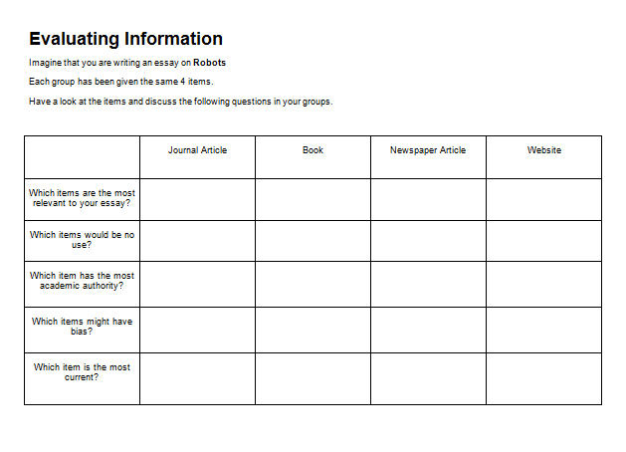
  - A peer reviewed journal article, which has citations, references, biographies of authors, but is several years old.
  - A book written by an expert in the 1980s.
  - Wikipedia article, which is very up-to-date, but has no authority.
  - Newspaper article from The Sun, which is sensationalist, uses non-academic language and is quite old.

2nd year workshop for UG Product Design students: Finding what you need

This workshop is intended to demonstrate the importance of using the right keywords in order to find the information needed.
Our presentation can be seen here:
http://www.slideshare.net/EISLibrarian/babsc-product-design-2nd-year-oct-2015

- The first exercise is designed to show that use of words is essential to communicate ideas and that there are different ways of describing things. Students are put in to pairs and should sit back to back. One person is the ‘drawer’ and the other is the ‘speaker’. The ‘drawer’ is given a blank piece of paper and a pen. The ‘speaker’ is given an image which they need to describe to the ‘drawer’ (who cannot see the image). Students should be given 3 minutes to complete this exercise, which means that the ‘speaker’ needs to carefully and succinctly describe the image. After 3 minutes the ‘drawers’ all show their drawings to the rest of the class and the correct version is displayed on the screen for all to see.

- The images below show the original image (left) and one example from class (right). Although similar, the right hand image is slightly different to the original and demonstrates the importance of choosing words and describing something carefully (emphasise that the same is true when searching a database i.e. what you put in, determines what you get out). See: 2nd year shapes activity2.docx
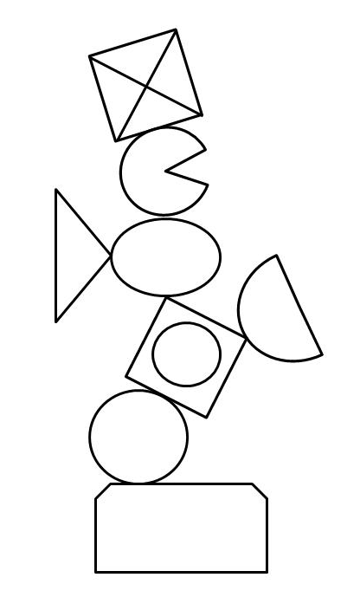

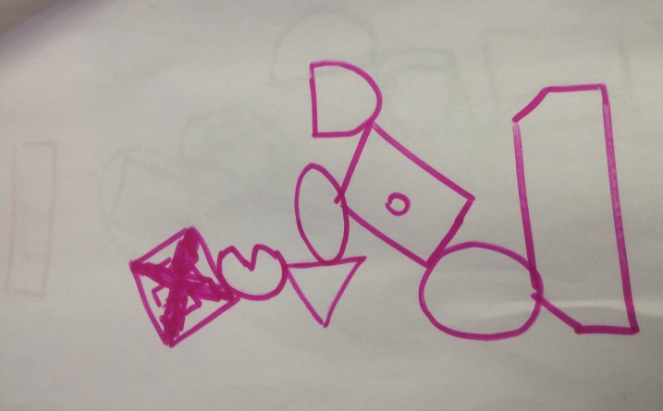

- The second activity builds on the first and is the same as the ‘Cup of tea’ exercise used with Foundation students (see above). See: 2nd year PDE Cup of tea.docx

- This workshop runs at the start of a student project, so time is included for students to have a go at searching for information with both the librarian and module leader present. They are also introduced to a number of search tips which might help them search more effectively (see presentation).

3rd year workshop for UG Product Design students: Information skills for research

This workshop is designed to support the final project which 3rd year students are working on. It is more traditional than the 1st and 2nd year workshops, but continues to be interactive including a number of activities to stimulate thinking, discussion and learning. An example of a 3rd year workshop can be seen below:
http://www.slideshare.net/EISLibrarian/3rd-year-product-design-oct-2015
- The workshop opens with a brainstorming exercise aimed at getting the students thinking about their project topic, possible search terms and related subjects. Each student is given a sheet of paper and a pen and asked to produce a mind map of their final project subject. The students then get in pairs and take turns to talk about their final project topic. The other person can ask questions, make suggestions etc. This exercise should take about 30 mins. At the end of this exercise, each student should have a piece of flip chart paper covered in ideas, words and phrases which might add to the content and direction of their project, but will also be useful when they start searching for information.

- Students than have a go at searching for their topic on Summon (our resource discovery tool) using some of the search terms that they have come up with during the brain storming exercise.

- The final activity is concerned with evaluating information sources and is the same as the ‘Evaluation game’ used in 2nd computing workshops (see above). See: 2nd year evaluation game.docx

Games we no longer use

Scenario game (3rd year students)
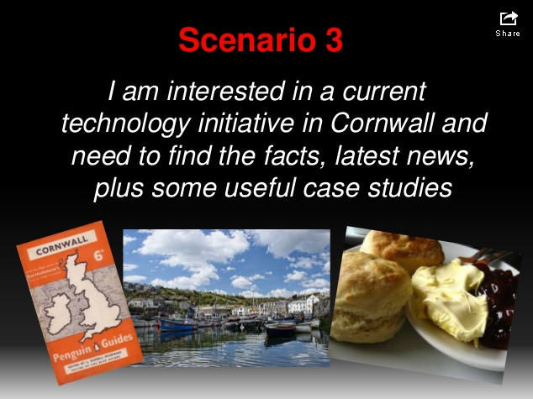
This is a variation on the 1st year ‘Thinking about resources’ game and works in a similar way. Create cards in same way as described for the ‘Thinking about resources’ card game.
Each group (ideally 3 students) is given a pack of cards containing 5 scenarios and a number of resources such as books, academic journals and conference proceedings.
Ask the students to consider the different scenarios and match against each one the resources that would best help them find suitable information.
The slides we use are in this set used for CMT3342:
http://www.slideshare.net/EISLibrarian/cmt3342-nov-2013information-skills-for-research
When all groups have completed the task, take feedback. Cover one scenario at a time. The feedback will allow various issues to be raised e.g. books might not be best for providing current information for Scenario 3 (above) as they become out-of-date. More suitable resources might be websites, trade journals and newspapers.
Having used this game in a few workshops we found that it was not very effective. Students lacked the initial understanding to participate and our questions demonstrated their ignorance rather than activating prior knowledge and allowing us to build on it. This game has been replaced with the ‘Reference list’ game.
See: V2 Scenario game D.Entry and PG.docx

9th Dec 2013
Last updated: 6^{h} April 2016 (version 9)

Boyle, S. (2011) Using games to enhance information literacy sessions, Presented at LILAC 2011. http://www.slideshare.net/infolit_group/boyle-using-games-to-enchance-information-literacy
http://www.kcl.ac.uk/study/learningteaching/kli/staff/markless.aspx
Turner, Alan. ‘What’s the name The Ideas Factory: a collaborative project for the information literate filmmakers of tomorrow’ presented at ARLIS UK & Ireland workshop ‘Getting creative: teaching information literacy to art and design students’. 24th June 2013. Goldsmiths, University of London. https://www.dropbox.com/sh/vdww7qu4yo6tita/nRKV76W4jQ

